Sri Lanka Institute of Information Technology



Lab Submission

<Lab sheet 06>

**<IT24101334>**

**<Dinod P.A.S.>**

**Probability and Statistics| IT2120**

B.Sc. (Hons) in Information Technology

Exercise

(i)

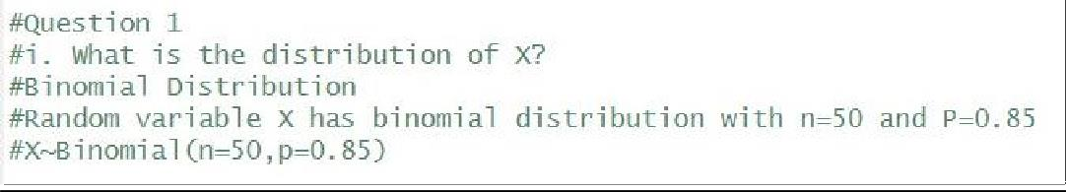

(ii)

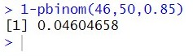

(i)

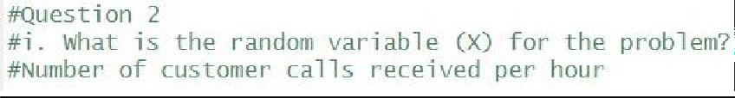

(ii)

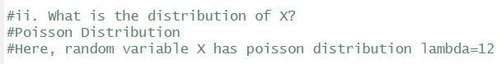

(iii)

